|  |  |  |  |  |  |
| --- | --- | --- | --- | --- | --- |
| Date | 10-Dec-22 | | | Tester Name | Mohammad Yusuf |
| Environment | Penfax - Test | | | Login used |  |
| Operating System | Windows | Version: | Update: | | |
| Software Used | Edge | Version: | Update: | | |
| Not Applicable | Version: | Update: | | |
| Release version |  | | | | |
| Title | E7 Fund Transfers | | | | |
| Test Type | Regression | | | | |
| Test Scenario | E7.02 Split the funds from 1 account to an asset allocation and a Specialty fund | | | | |
|  |  | | | | |
| Expected Results | 1. Interfund Transfer should be processed and displayed under member’s account in Penfax and in Member PLANet. 2. PEPP Interfund Transfer Letter should be available. 3. Transcation should be listed on the Daily Valuation Report. | | | | |
| Pass/Fail | Pass | | | JIRA# | N/A |

Describe your steps with screenshots:

1. Go to Member Search -> Filter to Plan PEPP, Member Type Employee and Member Status to Active.

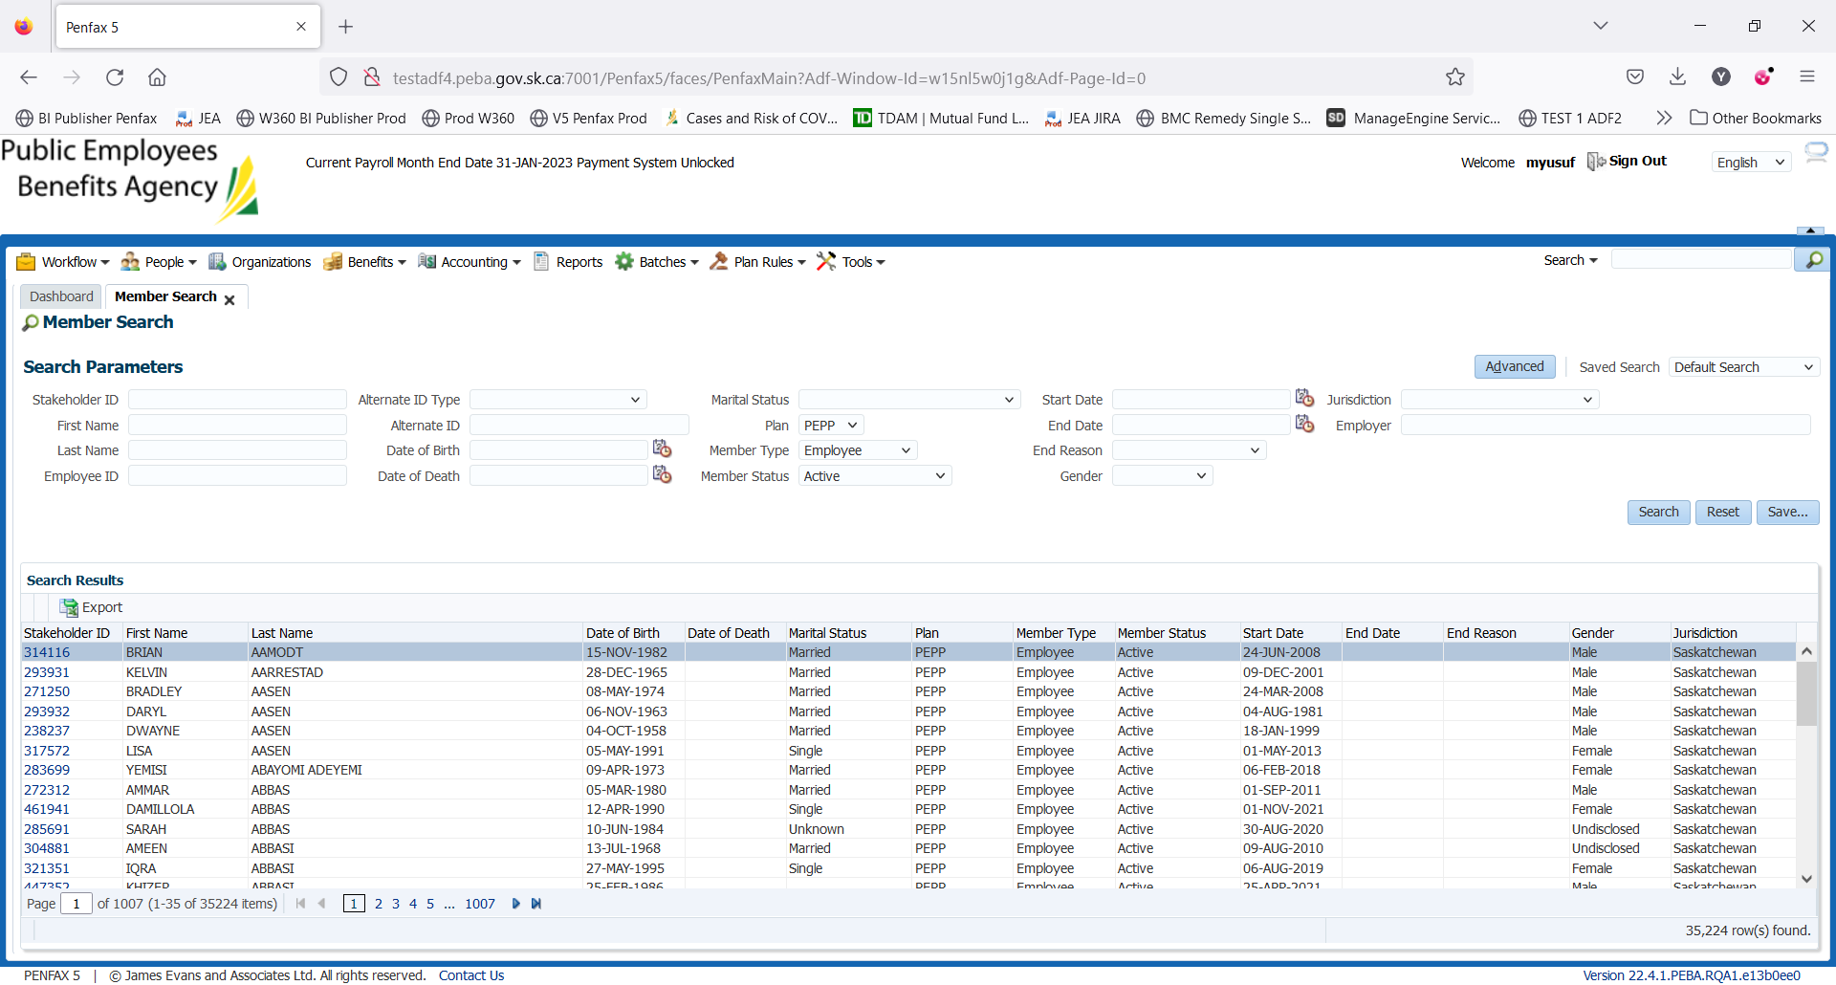

1. Click on one of the Stakeholder IDs.
2. Click on Investments on the Navigation panel.

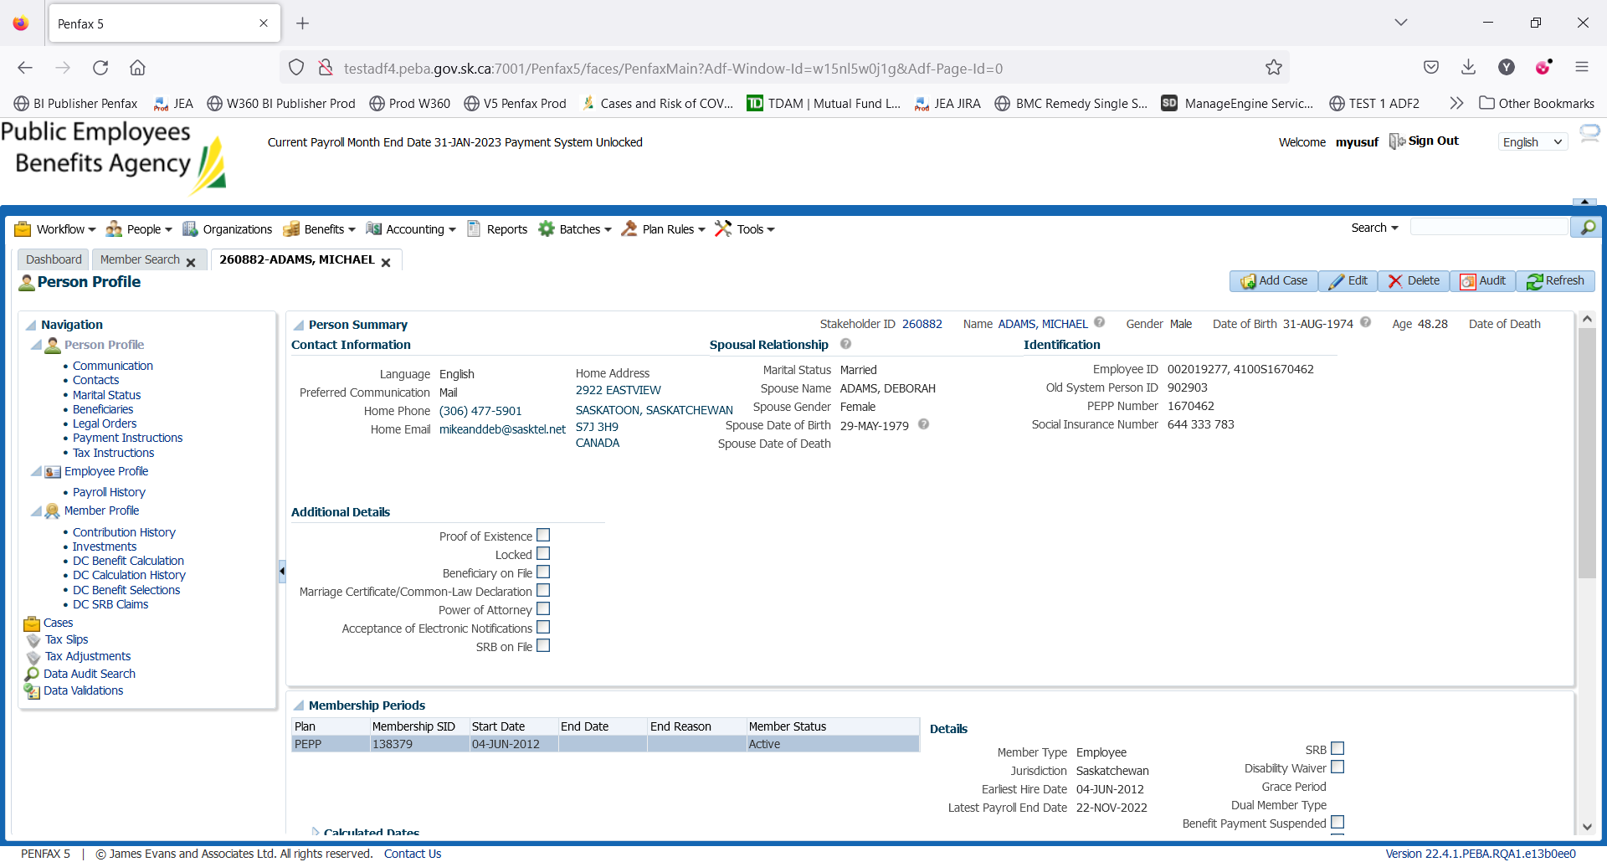

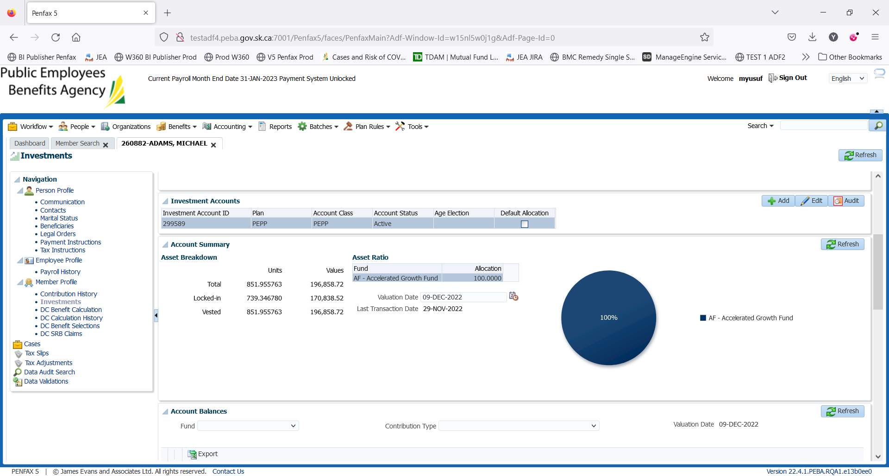

1. Scroll down and open up the Account Instructions Tab. Take note of what the current instructions are. Here, the current deposit allocation is 100% in AF. Click Add

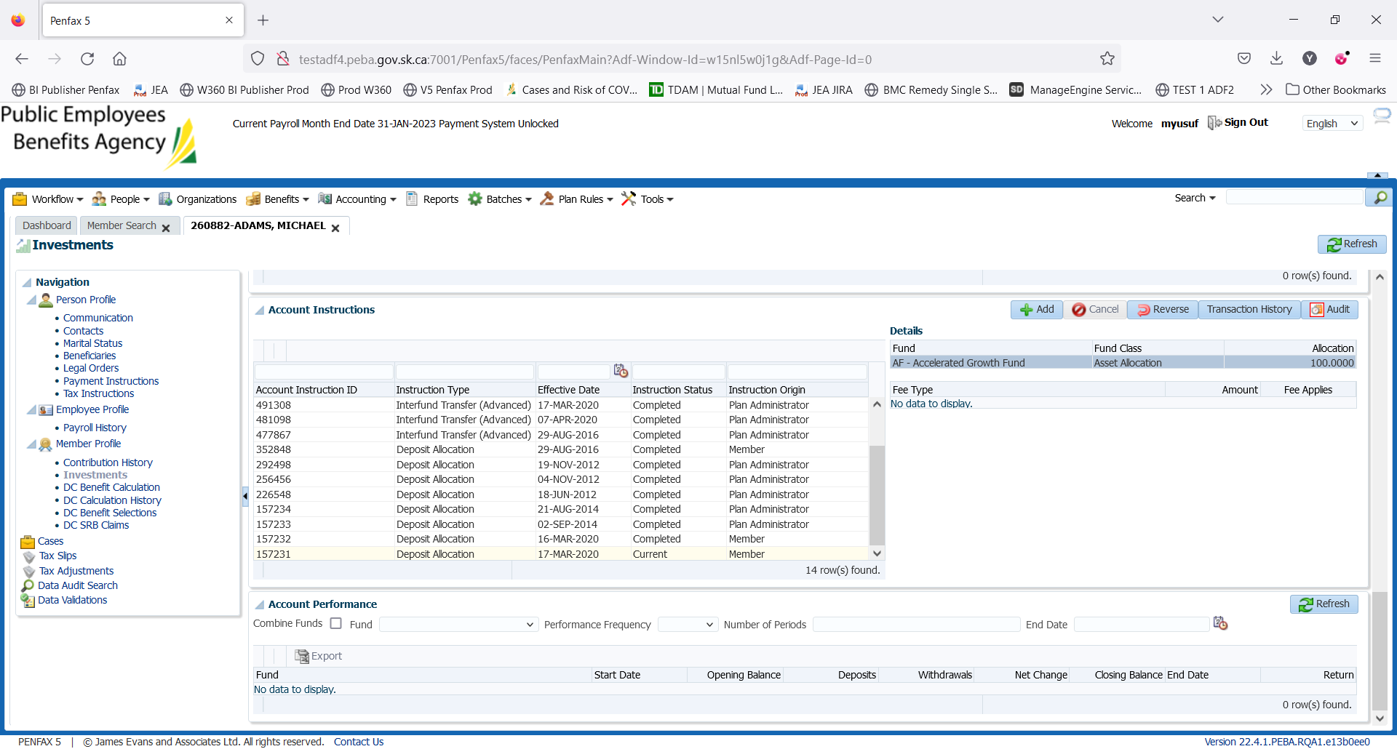

1. Under Instruction Type select Interfund Transfer (Basic).

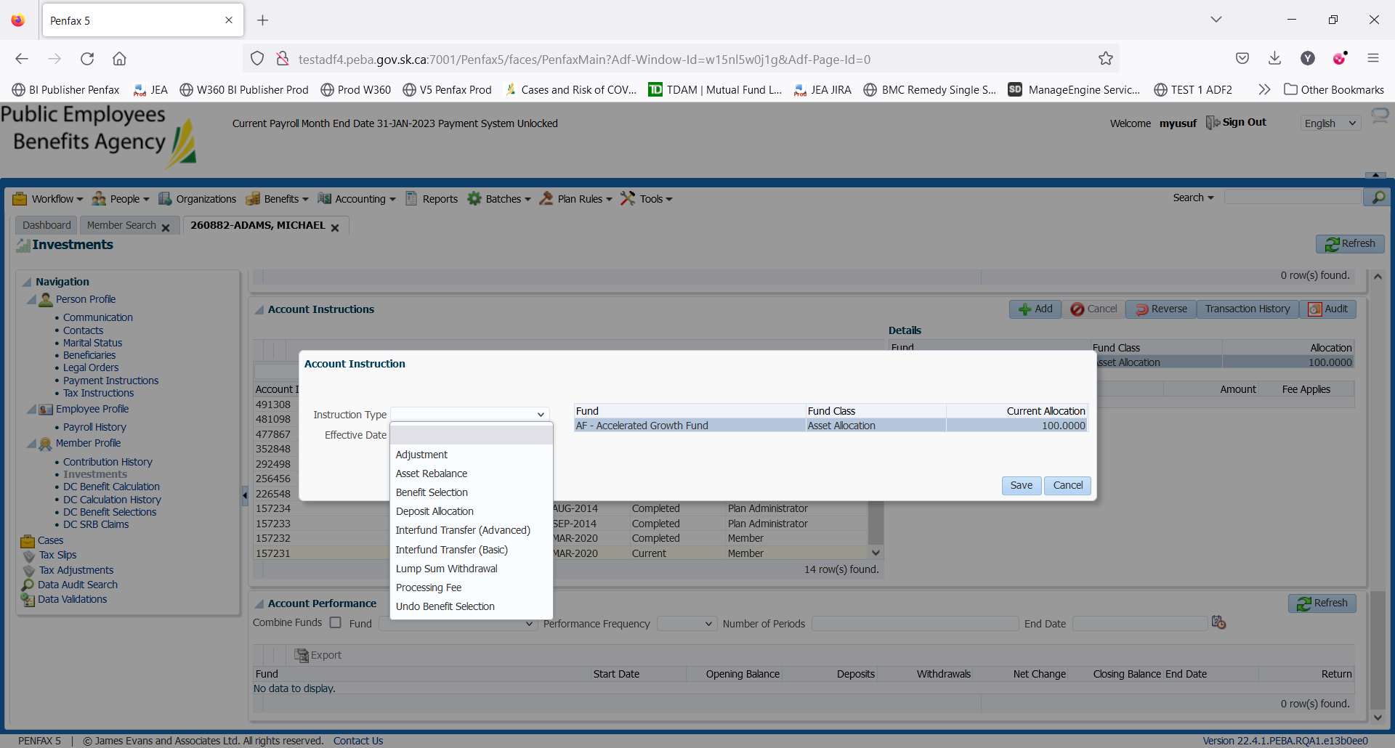

1. Click Add. Leave ‘Effective Date’ and ‘Fee Applies’ as they are. You can see where the current deposit allocation instruction on top right corner.

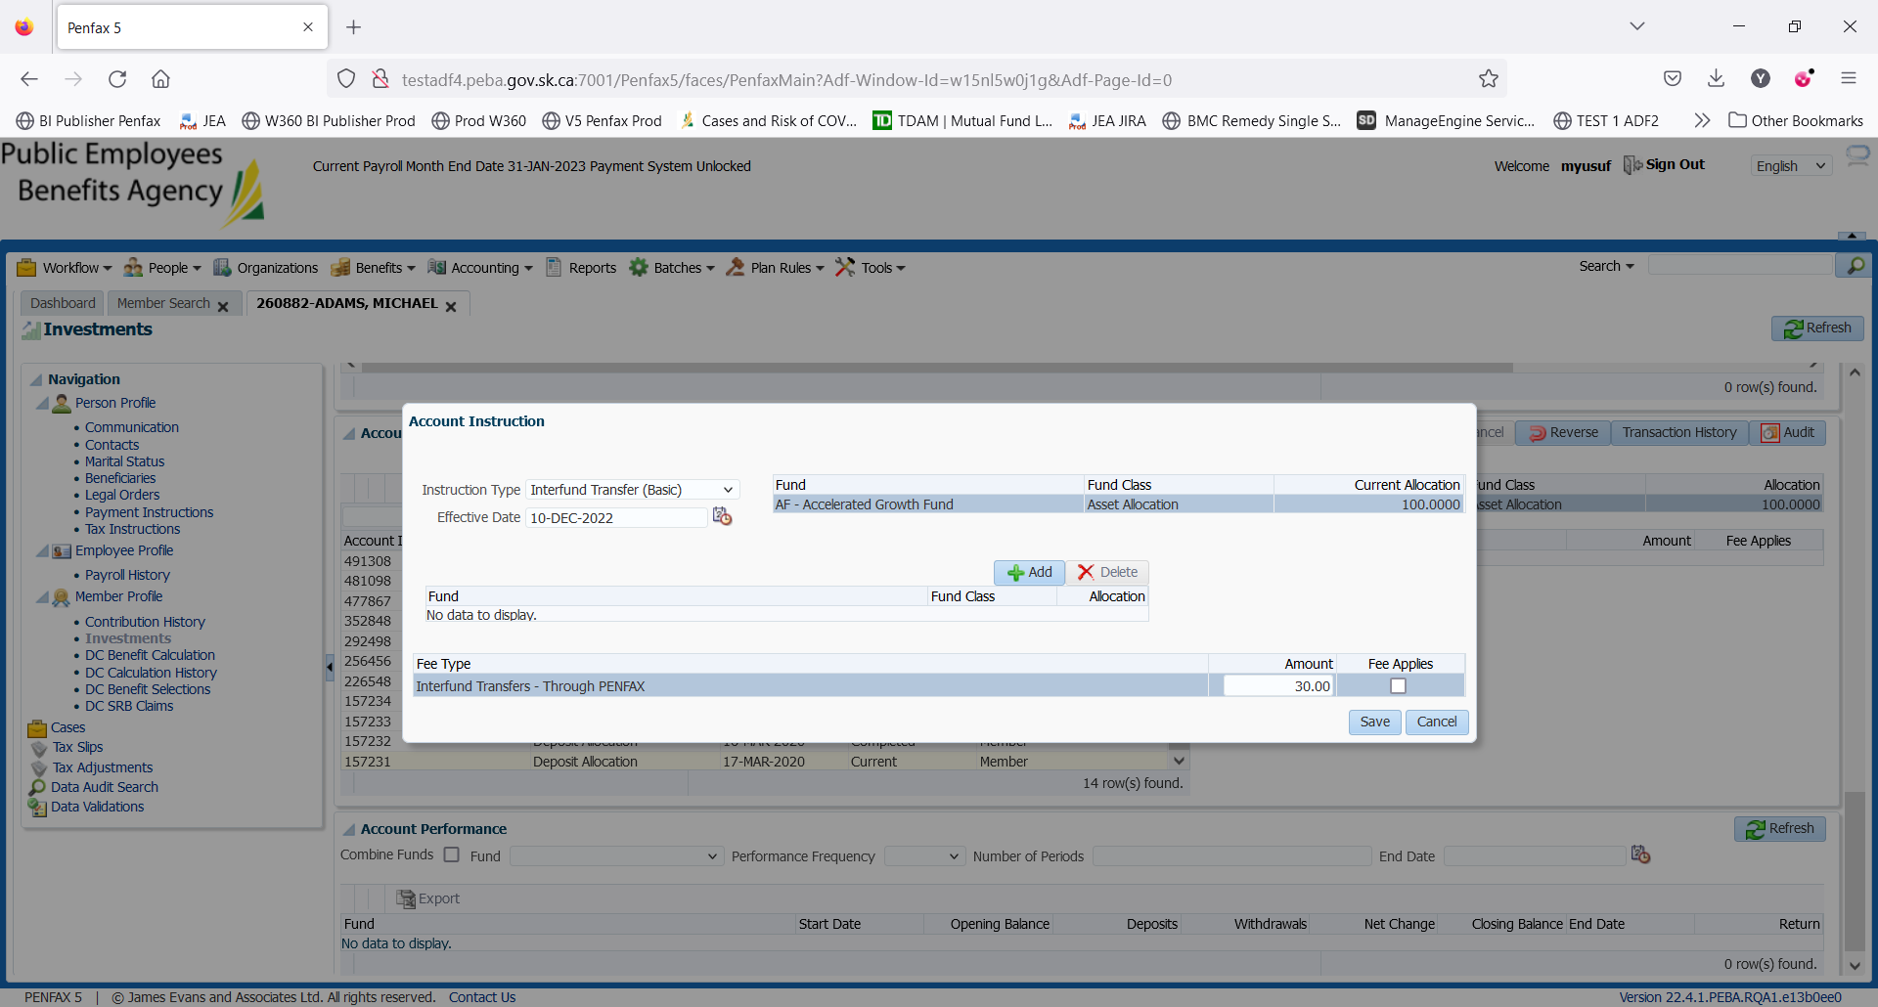

1. Select 1 asset allocation fund and 1 specialty fund to which you want to transfer and input percentage of allocation and click Save. You can transfer the current fund to more than 1 fund.

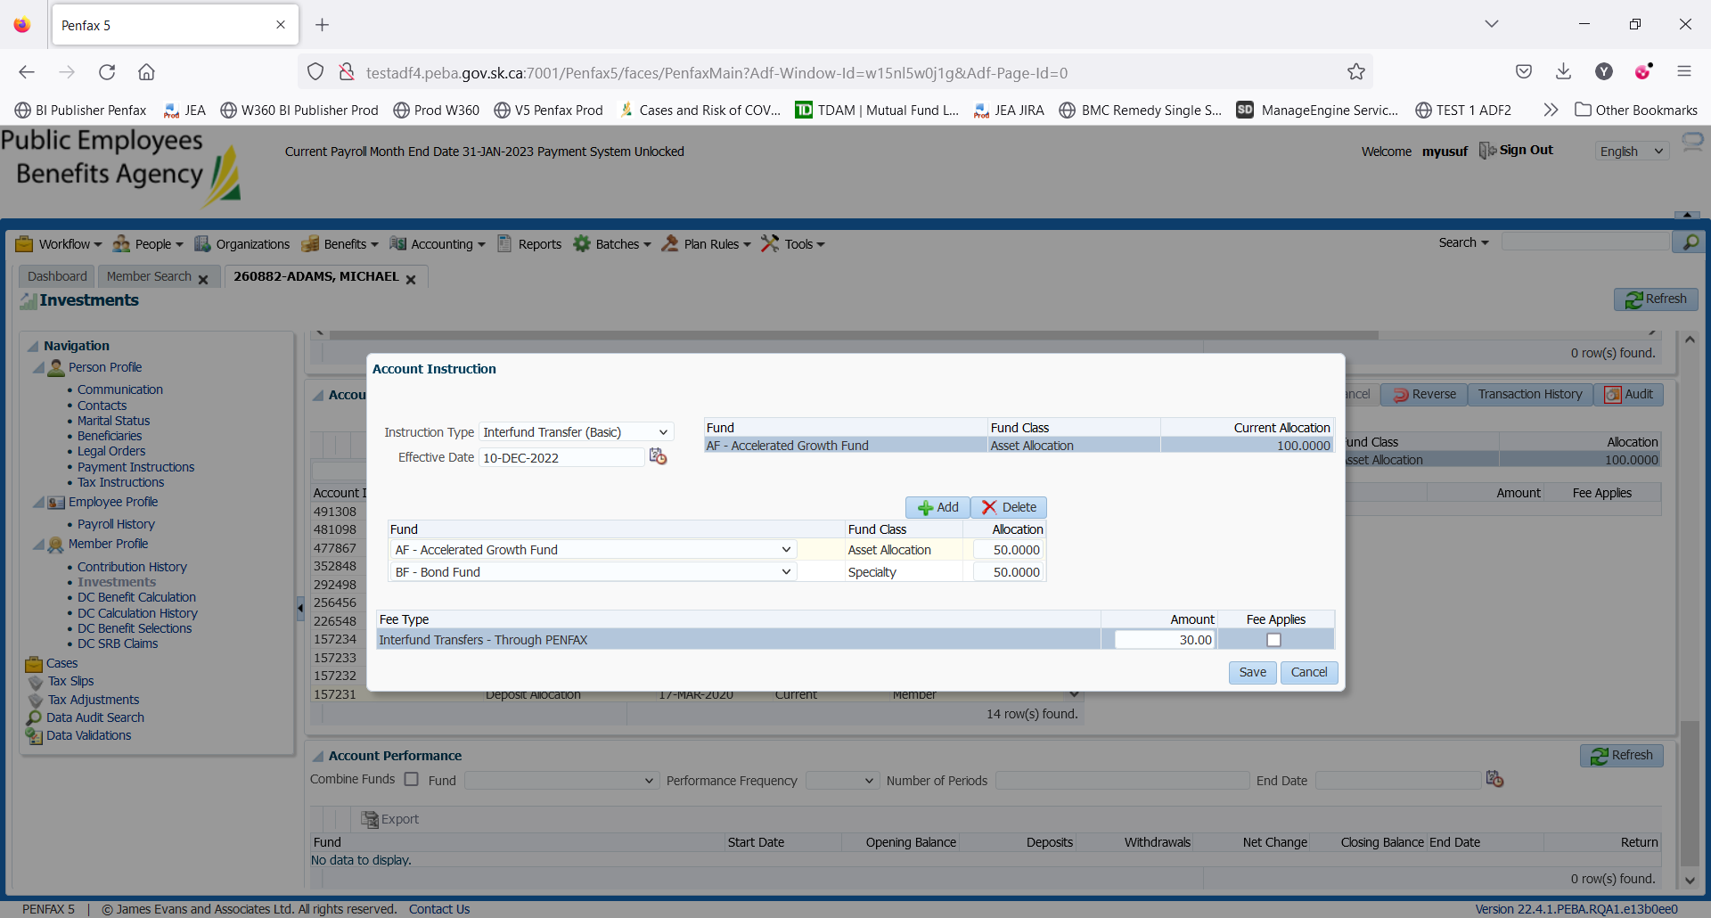

1. A new Instruction Type can be seen under Account Instruction with Pending Instruction Status.

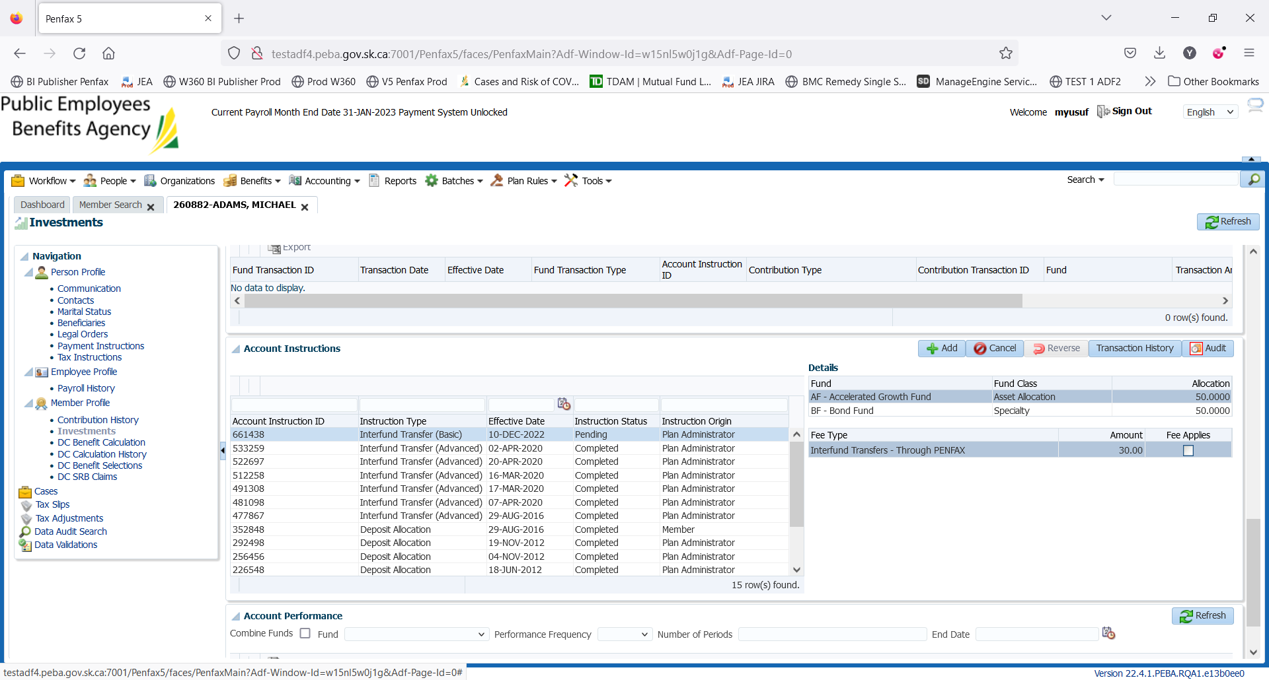

1. Member can see this pending Interfund Transfer in Member PLAnet (PENWEB).

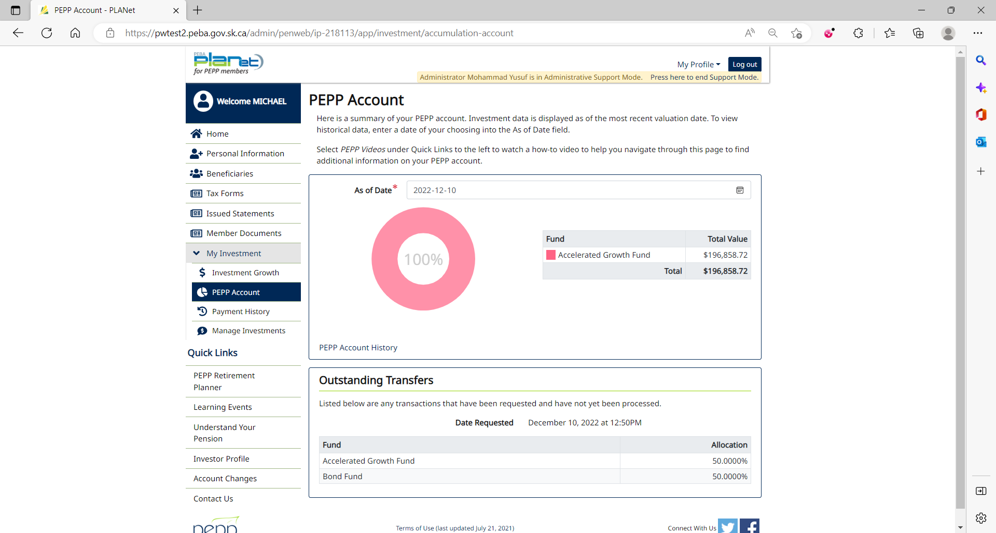

1. PIT batch was run overnight.
2. As per the Interfund Transfer processed yesterday (May 24, 2022), funds have been transferred 50% to BF and 50% to AF.

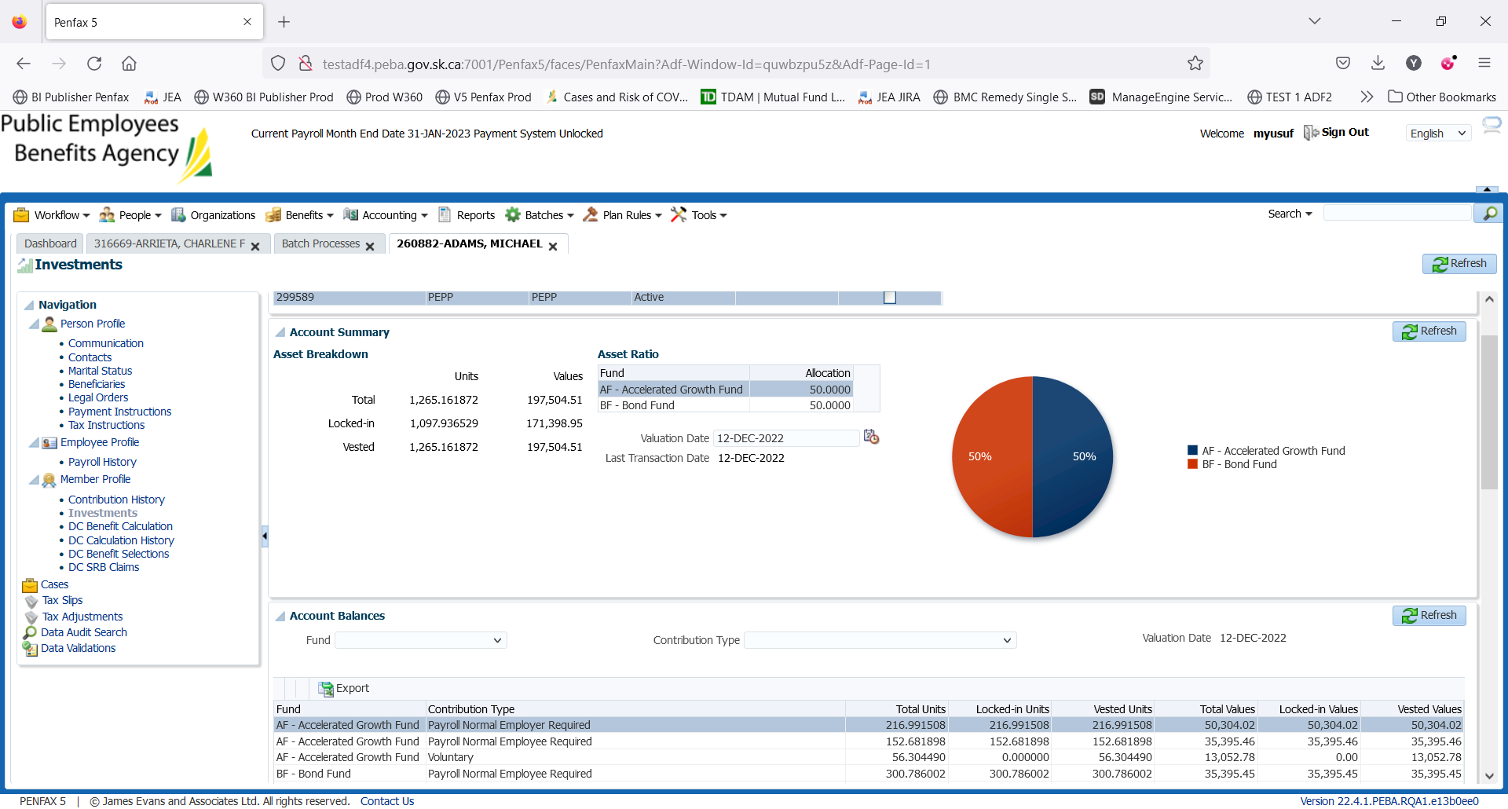

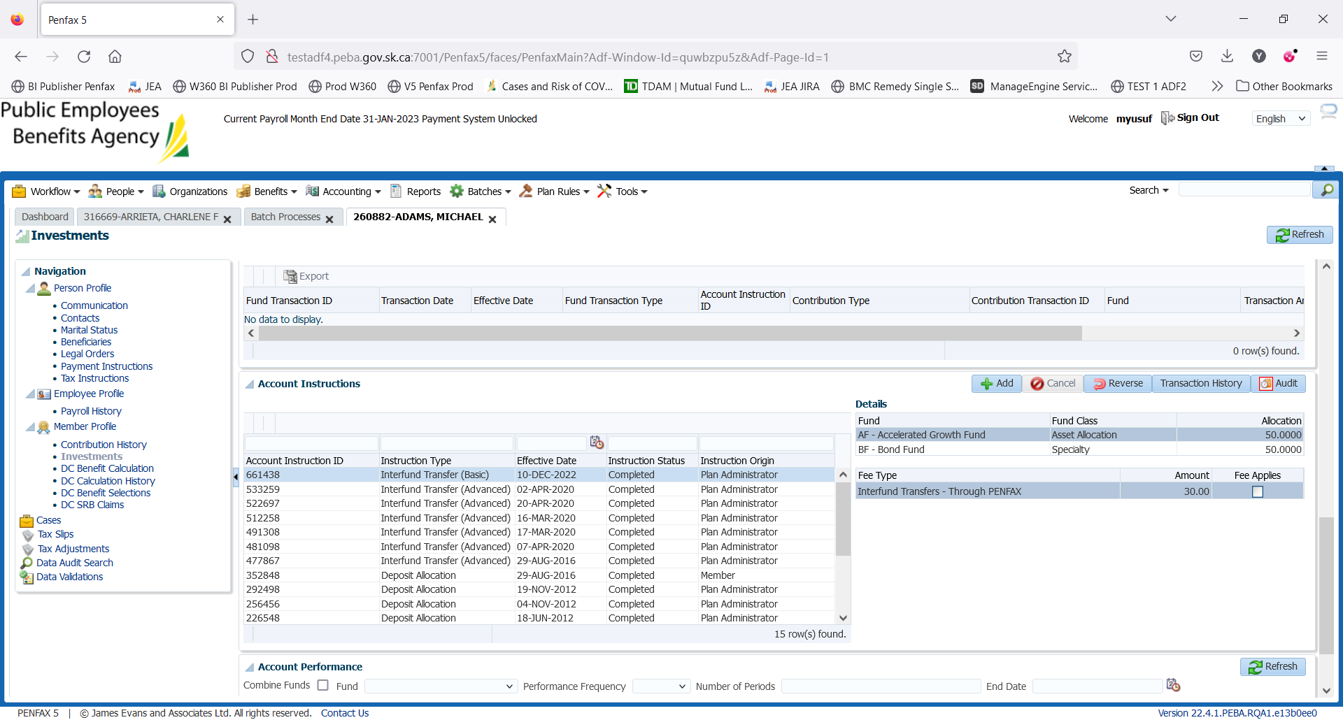

Transaction History of Interfund Transfer

1. PEPP Interfund Transfer letter is available under Person Profile -> Communication -> Outbound Documents.

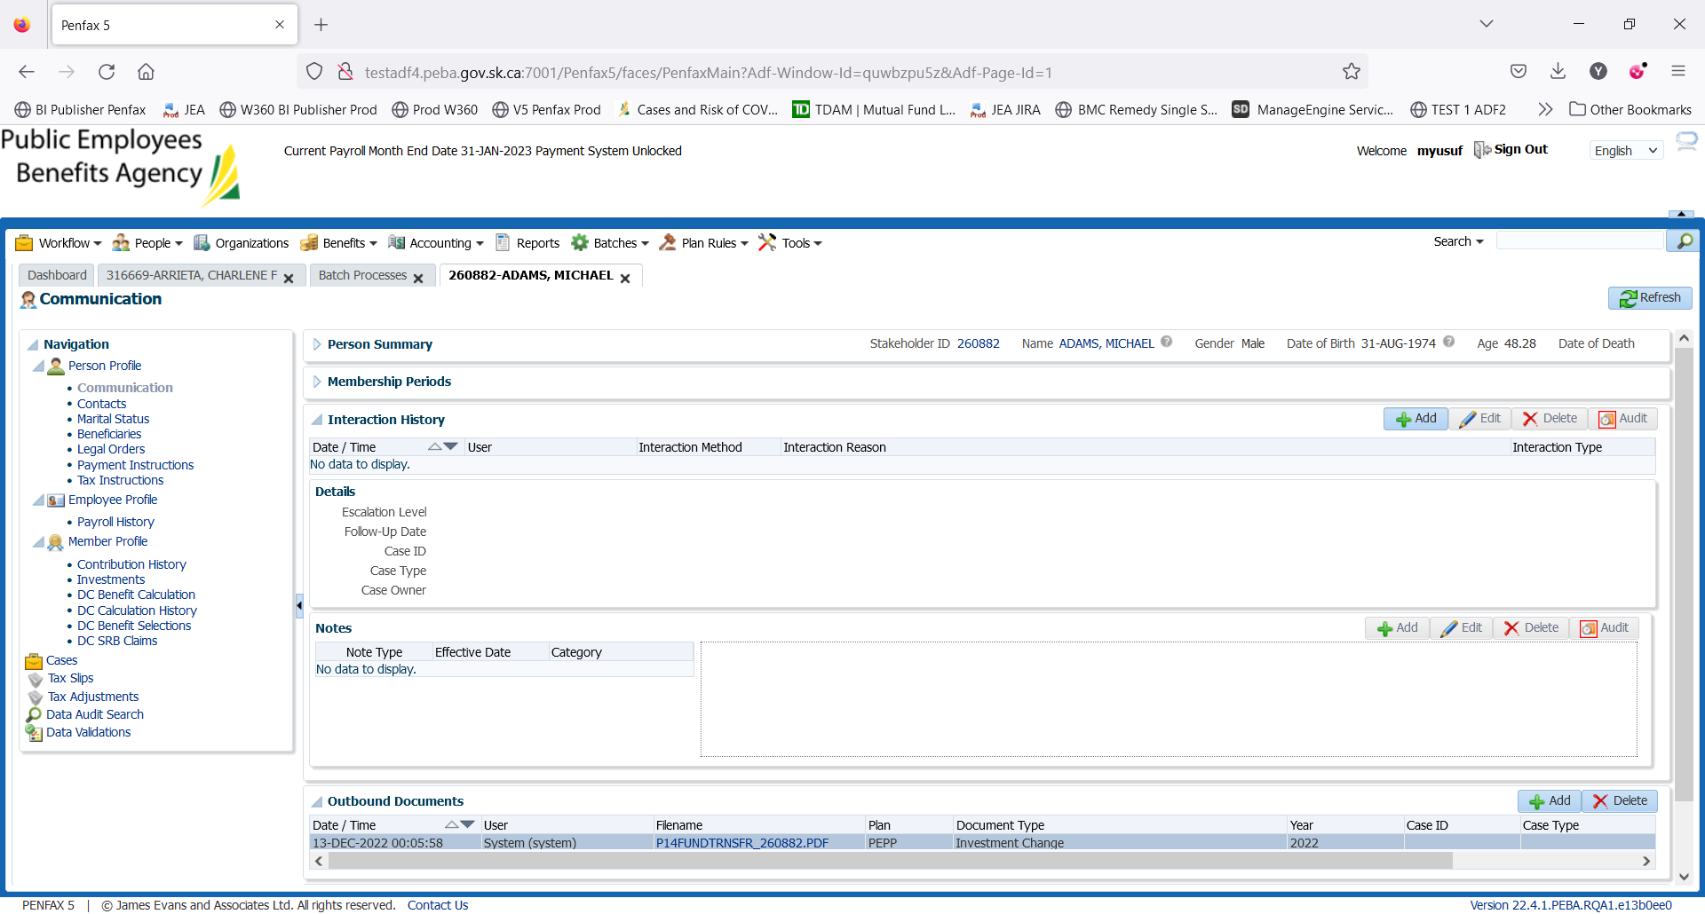

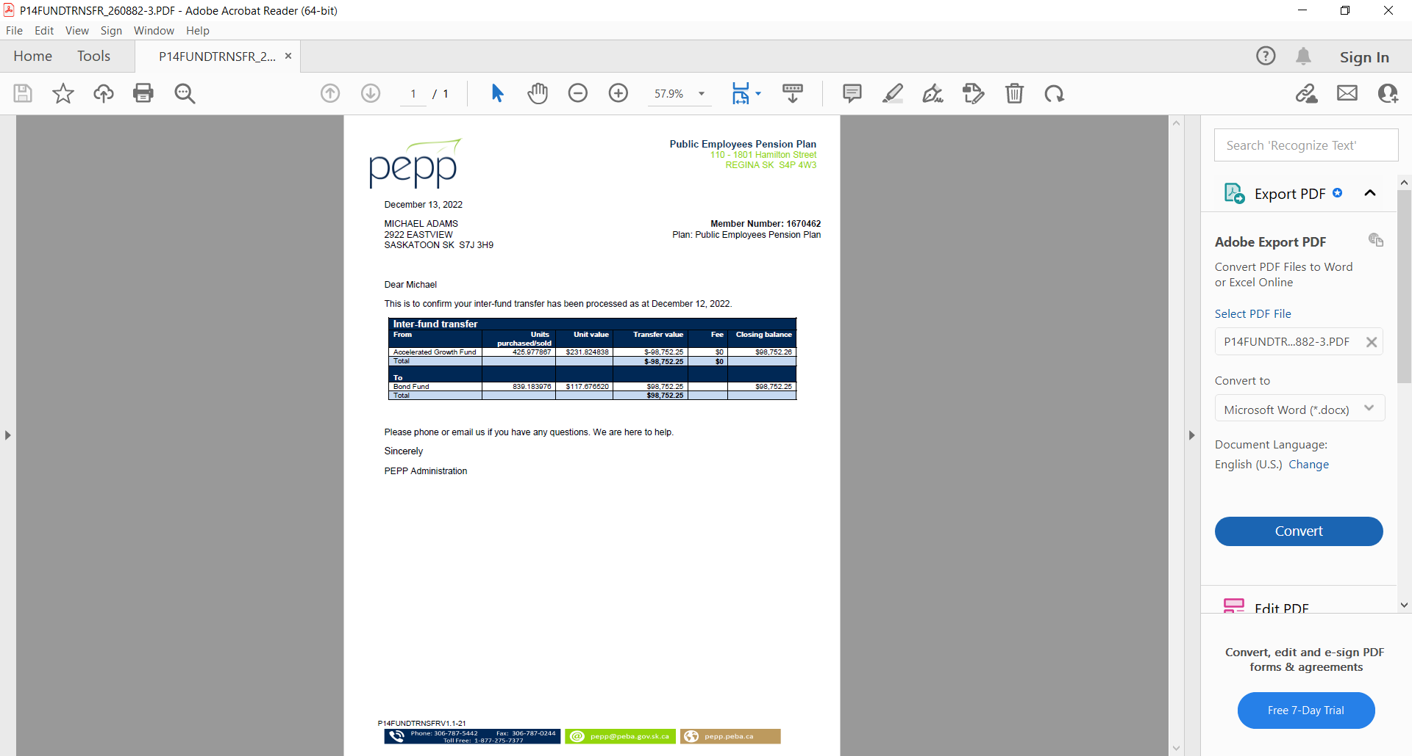

1. Check the Valuation Report. Go to Batches -> Batch Processes. Search with “PEPP Valuation Report” as Batch Process Type and open the very first record in the list (batch processed a day before).

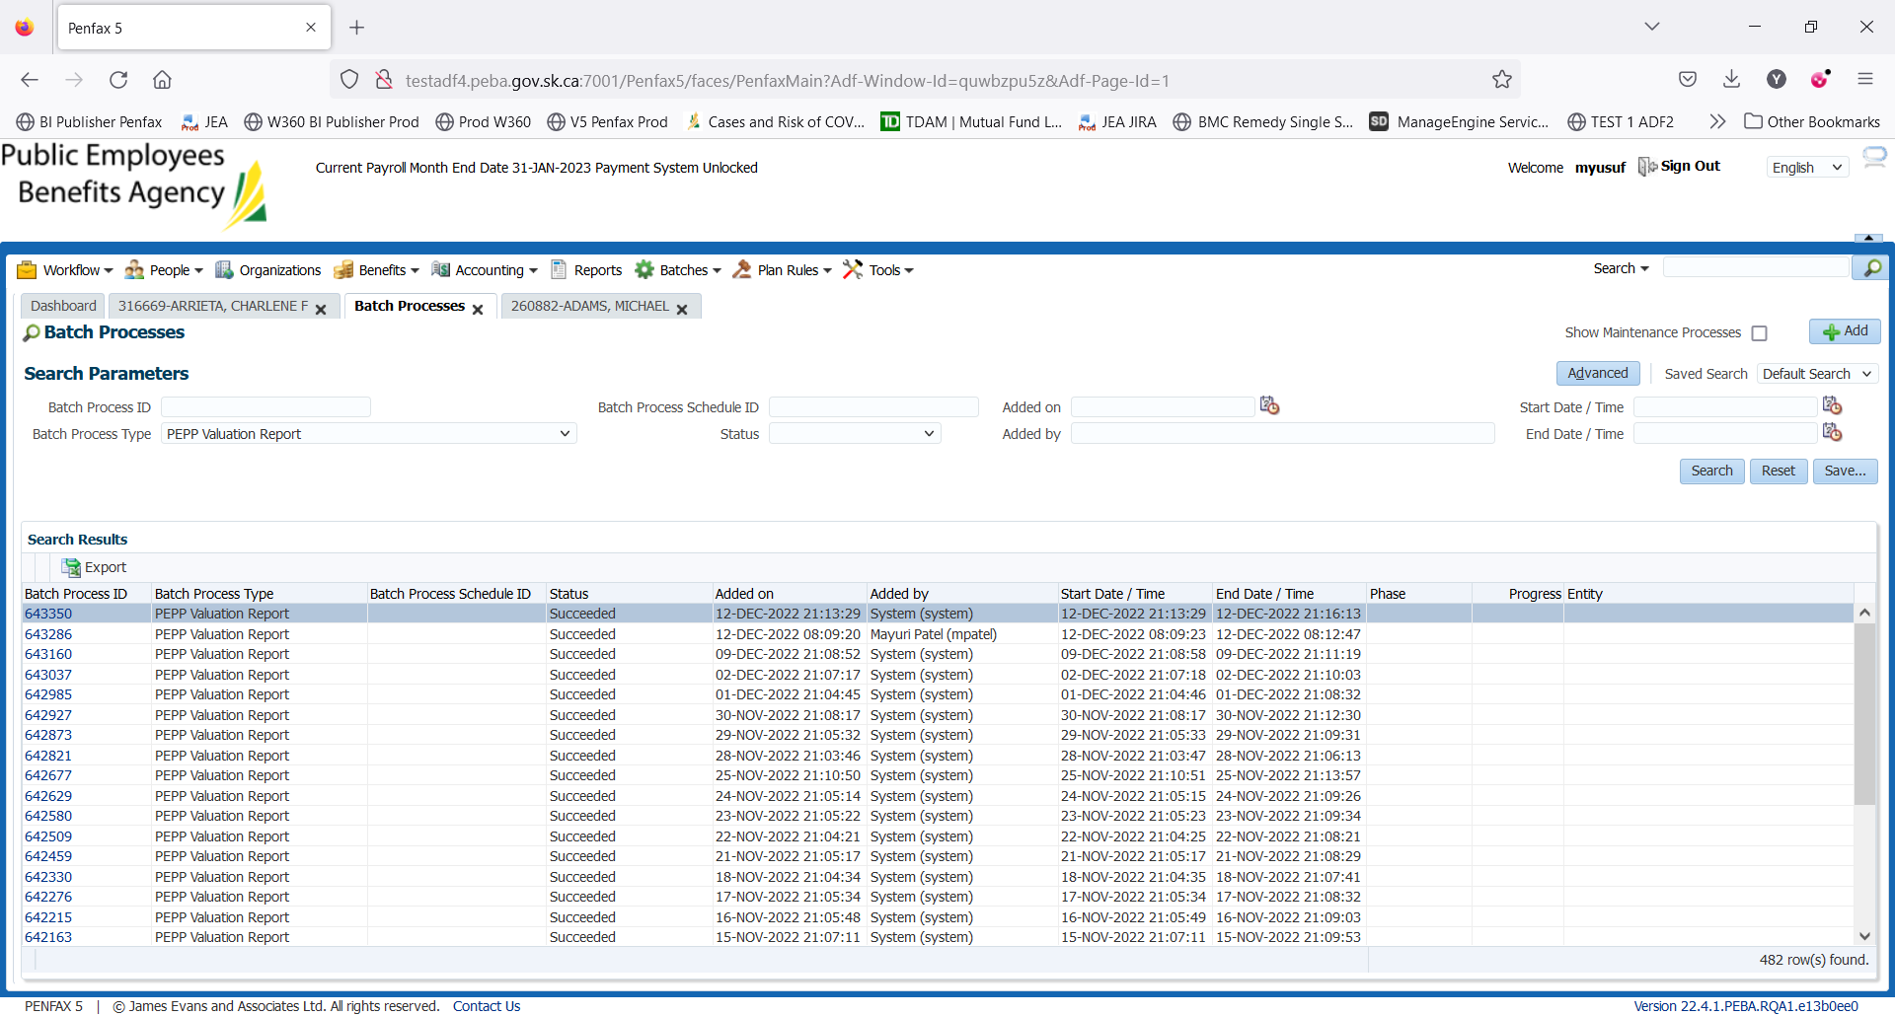

Go to Files tab and open PEPP valuation excel.

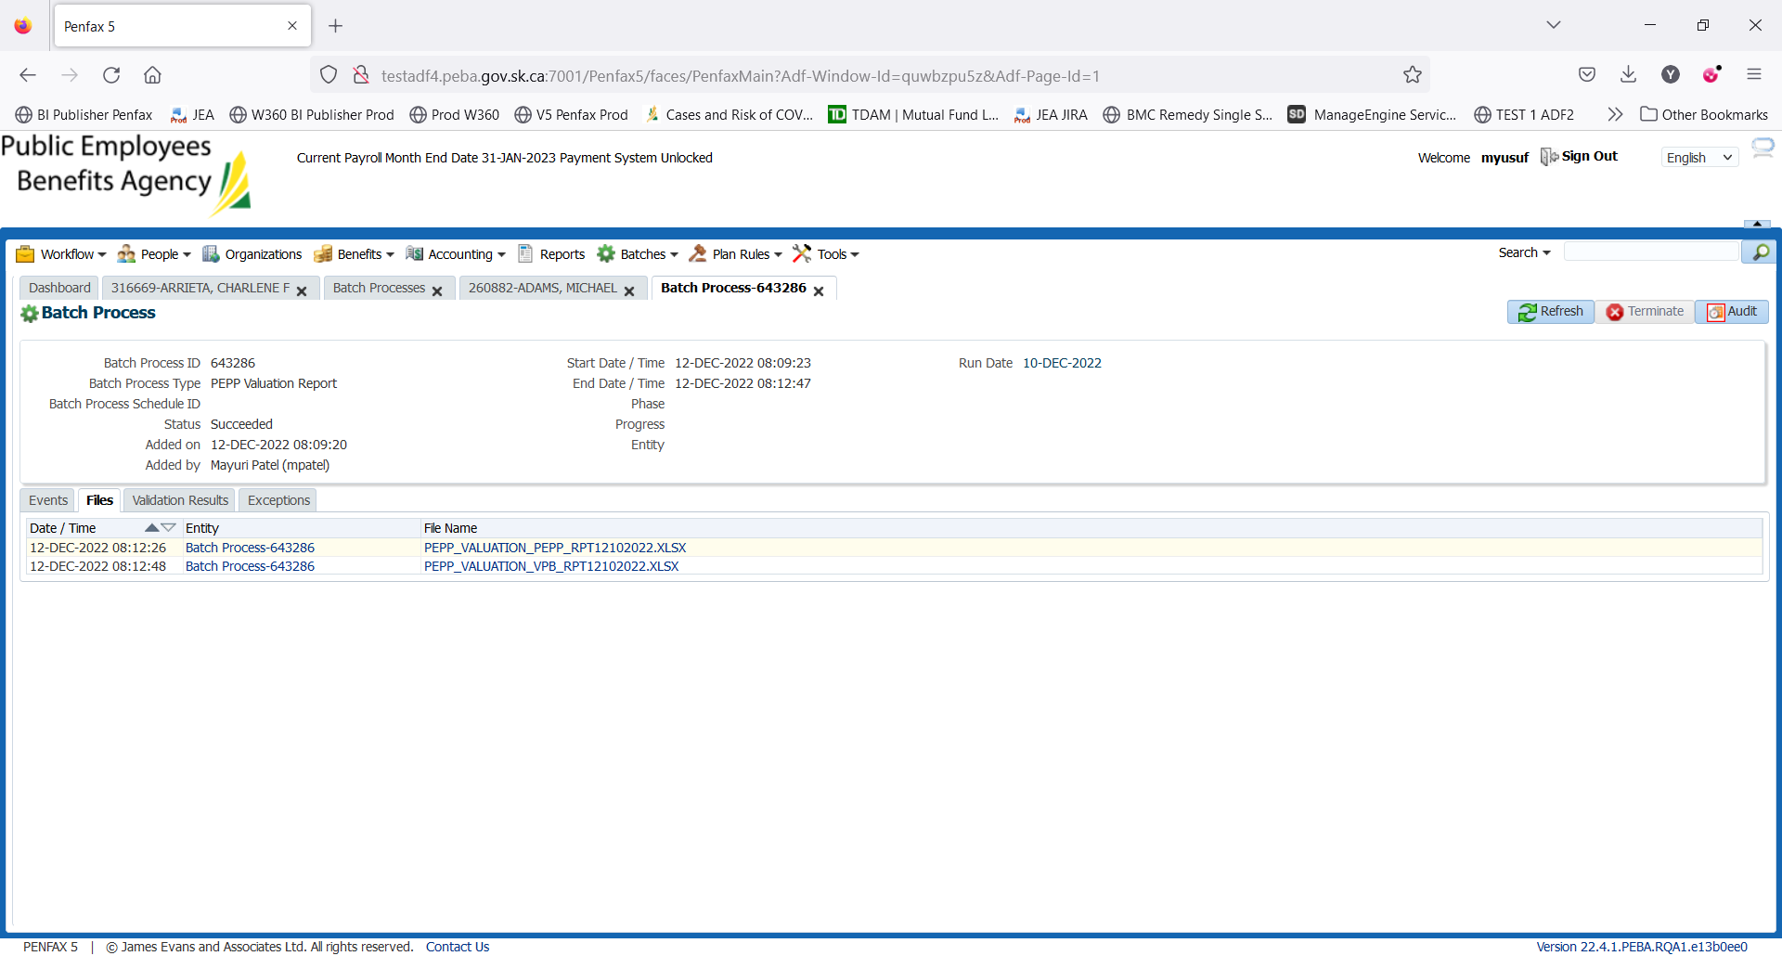

Section Four (Transfer In)

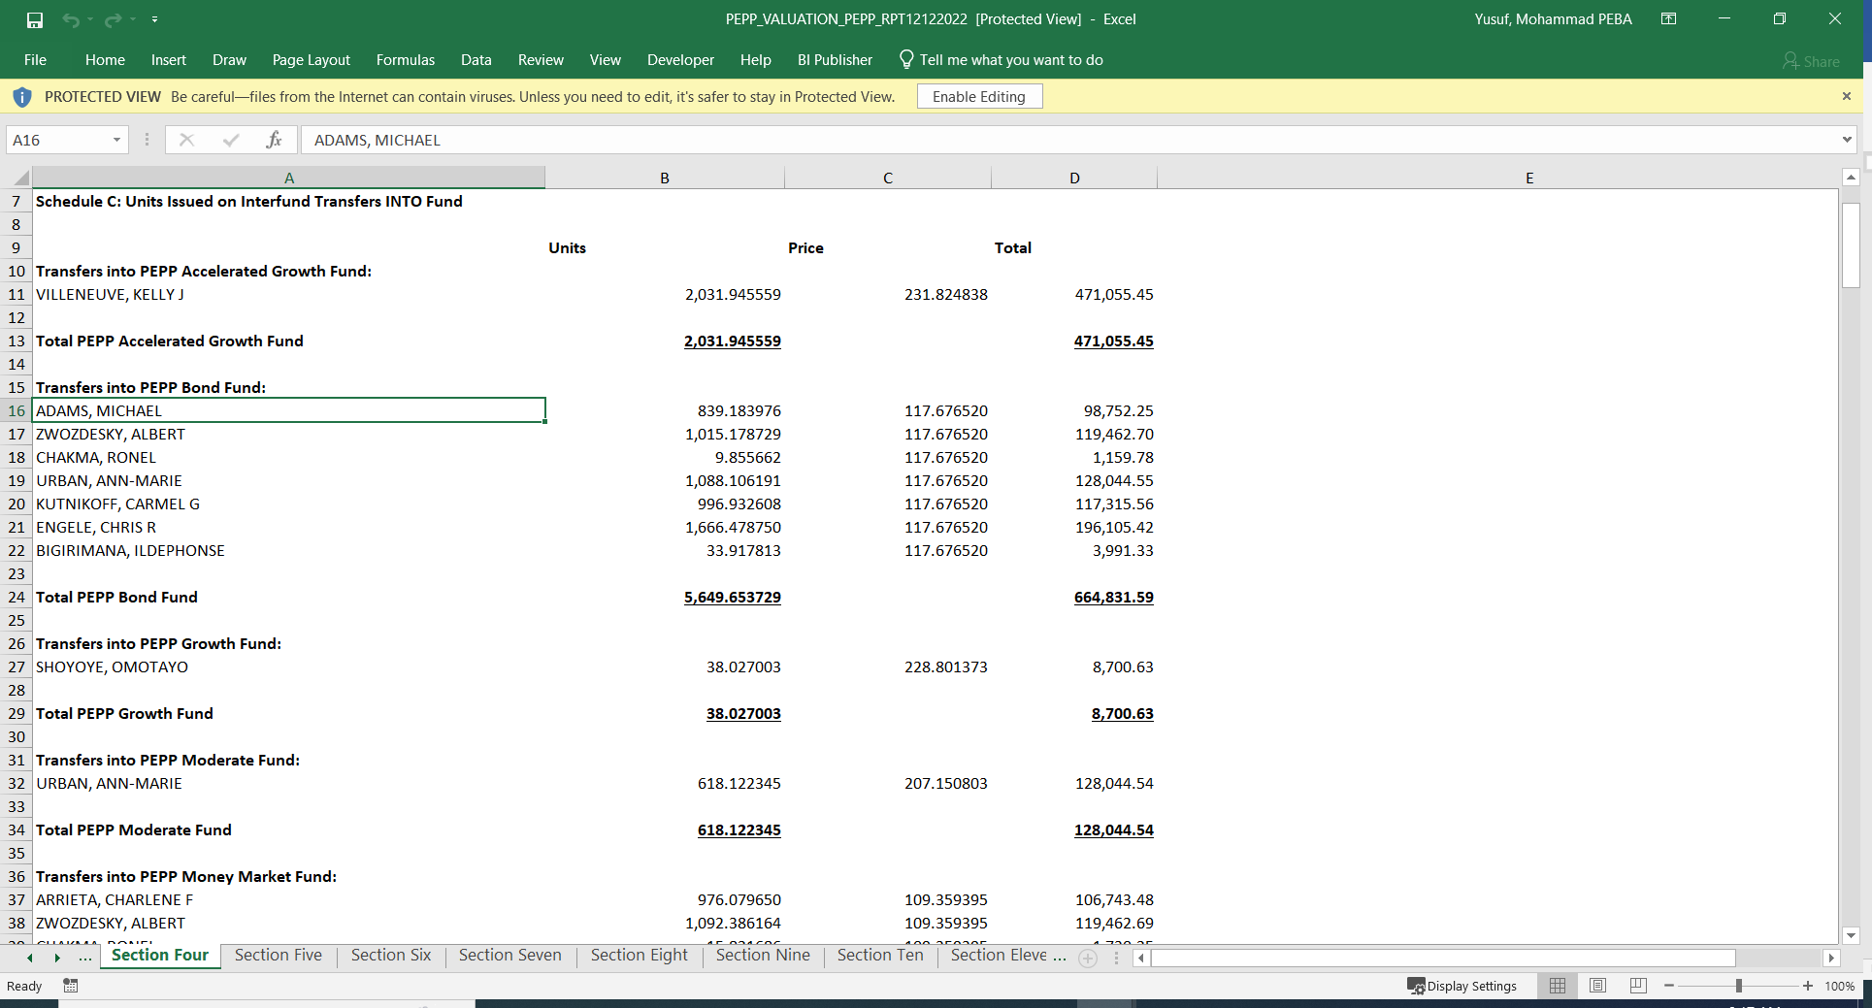

Section Nine (Transfer Out)

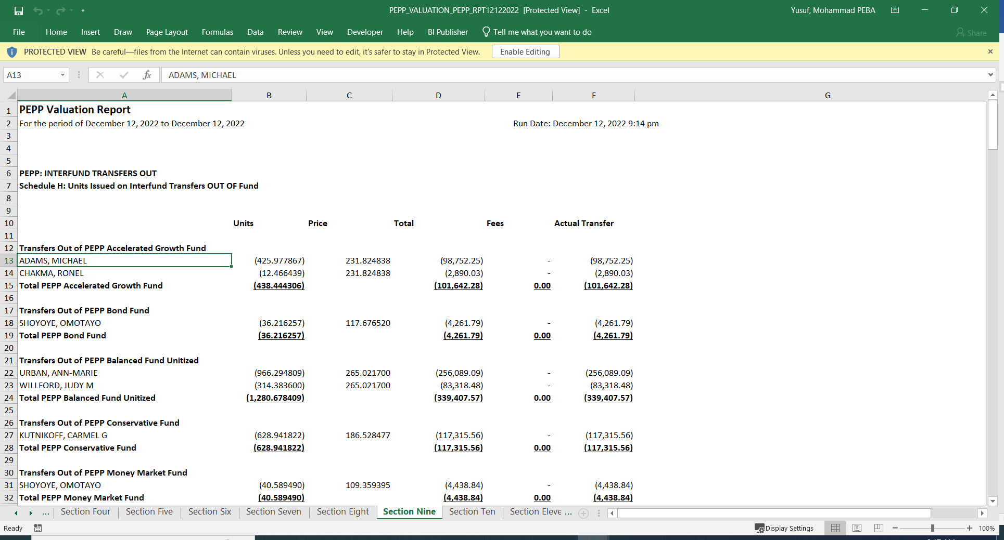

1. Member PLANet -> My Investment -> PEPP Account

